第九章

1. (1) √

(2) X

(3) √

(4) X

(5) √

(6) √

(7) √

(8) √

(9) X

(10) √

2. (1) A

(2) D

(3) B

(4) A

(5) B

(6) D

(7) D

3. (1) A

(2) D

(3) B

4. (1) 20:58:18

(2) 7:hello

(3) 苹果

(4) 4:6 日

5.

(1)

import java.util.InputMismatchException;

import java.util.Scanner;

import java.lang.String;

public class Test{

public static void main(String args[]){

String s = "数学87分，物理76分，英语96分";

Scanner scanner = new Scanner(s);

scanner.useDelimiter("[^0123456789.]+");

double sum = 0;

while (scanner.hasNext()){

try{

double num = scanner.nextInt();

sum += num;

}

catch(InputMismatchException exp){

String t = scanner.next();

}

}

double avg = sum/3.0;

System.out.println("总分：" + sum);

System.out.println("平均分：" + avg);

scanner.close();

}

}

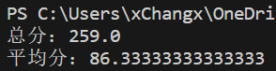

(2)

import java.time.DayOfWeek;

import java.time.LocalDate;

import java.util.Scanner;

public class Calendar {

private int year;

private int month;

public Calendar(int year, int month) {

this.year = year;

this.month = month;

}

public void show() {

LocalDate Now = LocalDate.now();

int yearNow = Now.getYear();

int monthNow = Now.getMonthValue();

int dayNow = Now.getDayOfMonth();

LocalDate date1 = LocalDate.of(year, month, 1);

DayOfWeek val = date1.getDayOfWeek();

int valday = val.getValue();

System.out.println(" 一 二 三 四 五 六 日");

System.out.println(" -----------------------------------");

for (int i = 0; i < (valday - 1); i++) {

System.out.print(" ");

}

int count = 1;

while (count <= date1.lengthOfMonth()) {

if (year == yearNow && month == monthNow && count == dayNow)

System.out.printf(" (%d)", count);

else

System.out.printf("%5d", count);

count++;

valday++;

if (valday > 7) {

valday -= 7;

System.out.println("");

}

}

}

public static void main(String[] args) {

Scanner reader = new Scanner(System.in);

System.out.println("请输入年份和月份");

int year = reader.nextInt();

int month = reader.nextInt();

reader.close();

Calendar calendar = new Calendar(year, month);

calendar.show();

}

}}

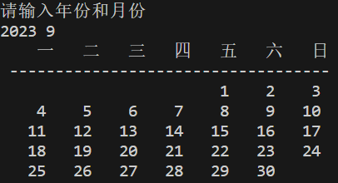

(3)

import java.util.Scanner;

import java.time.LocalDate;

import java.time.temporal.ChronoUnit;

public class Test{

public static void main(String args[]){

Scanner scanner = new Scanner(System.in);

int year1, month1, day1, year2, month2, day2;

year1 = scanner.nextInt();

month1 = scanner.nextInt();

day1 = scanner.nextInt();

year2 = scanner.nextInt();

month2 = scanner.nextInt();

day2 = scanner.nextInt();

LocalDate Date1 = LocalDate.of(year1, month1, day1);

LocalDate Date2 = LocalDate.of(year2, month2, day2);

System.out.println(Date1.until(Date2, ChronoUnit.DAYS));

scanner.close();

}

}

